HUMA 1850A The Bible in Modern Contexts
Wisdom Literature
November 19, 2018

- Chapter Three (pp. 69-74) — Wisdom Overview
  - Ecclesiastes/Qohelet urges an “imperative of joy” — what is this?
  - Proverbs shows evidence of borrowing from what other ancient foreign text?
  - How is wisdom depicted in Proverbs?
  - How does Proverbs contrast with Ecclesiastes/Qohelet?
- Introduction
- Ancient Near Eastern Literature containing parallels to the Old Testament
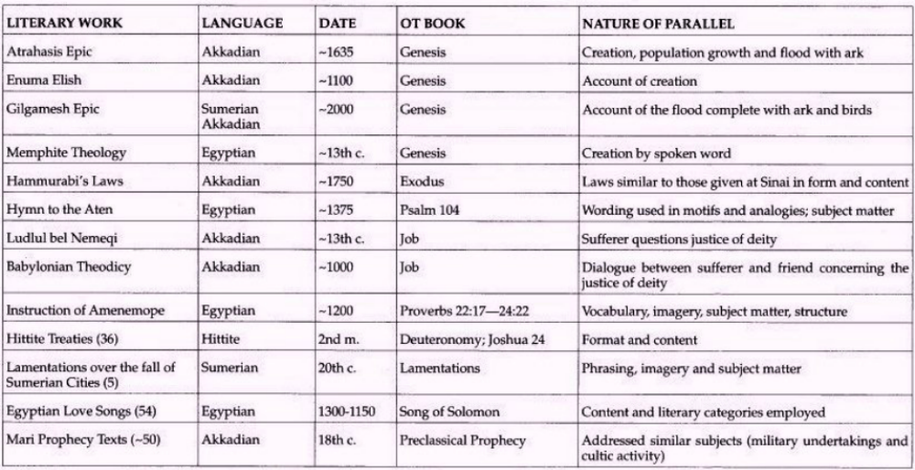
- Characteristics of Wisdom Genre
- Wisdom Theme Runs through the Bible (Read before class)
  - Eve’s dialogue with the serpent (Gn 3:1-6)
  - Jacob and his gain of Laban’s flock (Gn 30:37-43)
  - Joseph’s answer to Potiphar’s wife (Gn 39:8-9)
  - Jethro advises Moses, his son-in-law (Ex 18:19-26)
  - Story of Nabal, Abigail and David (1 Sm 25:2-38)
  - Tamar urging Amnon not to rape her (2 Sm 13:12-13)
  - Solomon and the two prostitutes (1 Kgs 3:16-28)
- Four Types of Wisdom Literature
  - Instructions
  - Argument
  - Narrative (Wisdom Tale)
  - Manticism
- Who were the Wise?
  - Wisdom and the scribal class
  - Wisdom as an intellectual tradition
  - Folk wisdom
- Difference between Wisdom and Prophecy
  - Introduction
  - Basic differences
    - Presuppositions and approaches
    - Distinct theologies
    - Concerns, objectives and methods
    - Characteristic ways of thought, vocabularies and literary forms
- Theodicy
  - Classical Greek inquiry
  - Monotheism — Only three possible answers to “Why the righteous suffer?”
- The Book of Job
  - The Literary Structure (see below)
  - Prologue (1-2) and Epilogue (42:7-12)
  - Job’s Opening Lament (3) and Job’s Closing Contrition (40:3-5; 42:1-6)
  - Dialogue Disputes (4-27) and Monologue Disputes (29-42)
  - Interlude on Wisdom (28)
- Tutorial: The Book of Ecclesiastes/Qohelet
  - State the tension in each of the following paradoxes: e.g., “This is true … Yet this is also true …” a. 2:13-14, b. 2:26, c. 3:17-18, d. 9:13-16, e. 9:18, f. 11:9
  - How is the problem of theodicy (God’s justice) described? a. 7:15, b. 8:10-11, c. 8:14
  - Summarize the teaching on death. a. 2:16, b. 3:19-21, c. 4:2-3, d. 9:1-6, e. 9:10
  - What can we know about God’s activity in this world? a. 8:17, b. 9:1, c. 11:5
  - Do you think Qohelet is a skeptic or a cynic? Why do you think so? Give evidence from the text to support your conclusion — Skeptic: An attitude of doubt, nothing can be known with certainty, Cynic: Believes that self-interest is the motive of all human conduct



